Payment in advance from COA
COA is created and registered with PAYTERM=PAYMENT IN ADVANCE
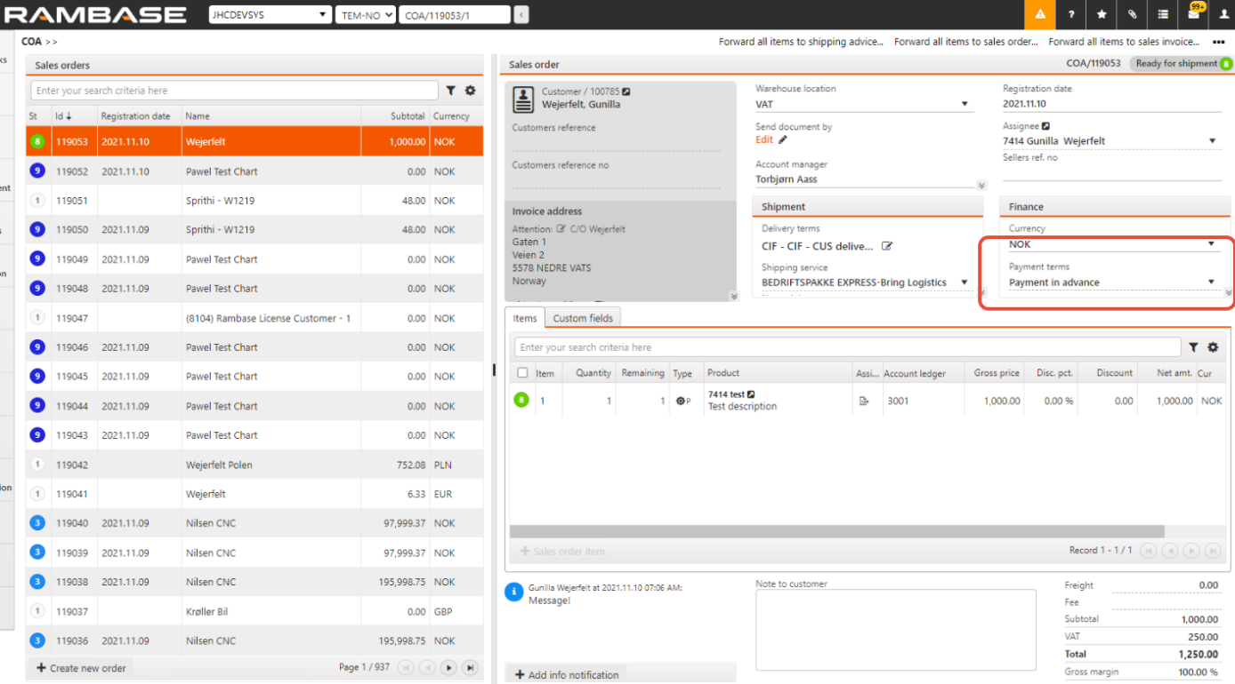

On COA item level there is a message that you can’t forward the COA to a Shipping advice before payment is registered. 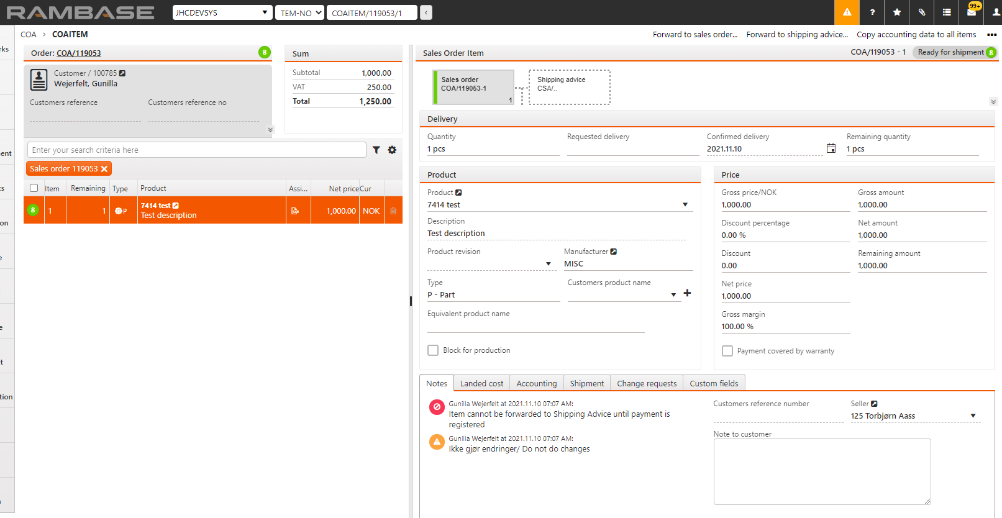

From the COA is ST=8, it could be triggered a Proforma Invoice that you can send to the customer. Please make sure the invoice is triggered from the COA.

When you receive payment, use the option Create payment from the COA. This is to bind the COA and the payment together.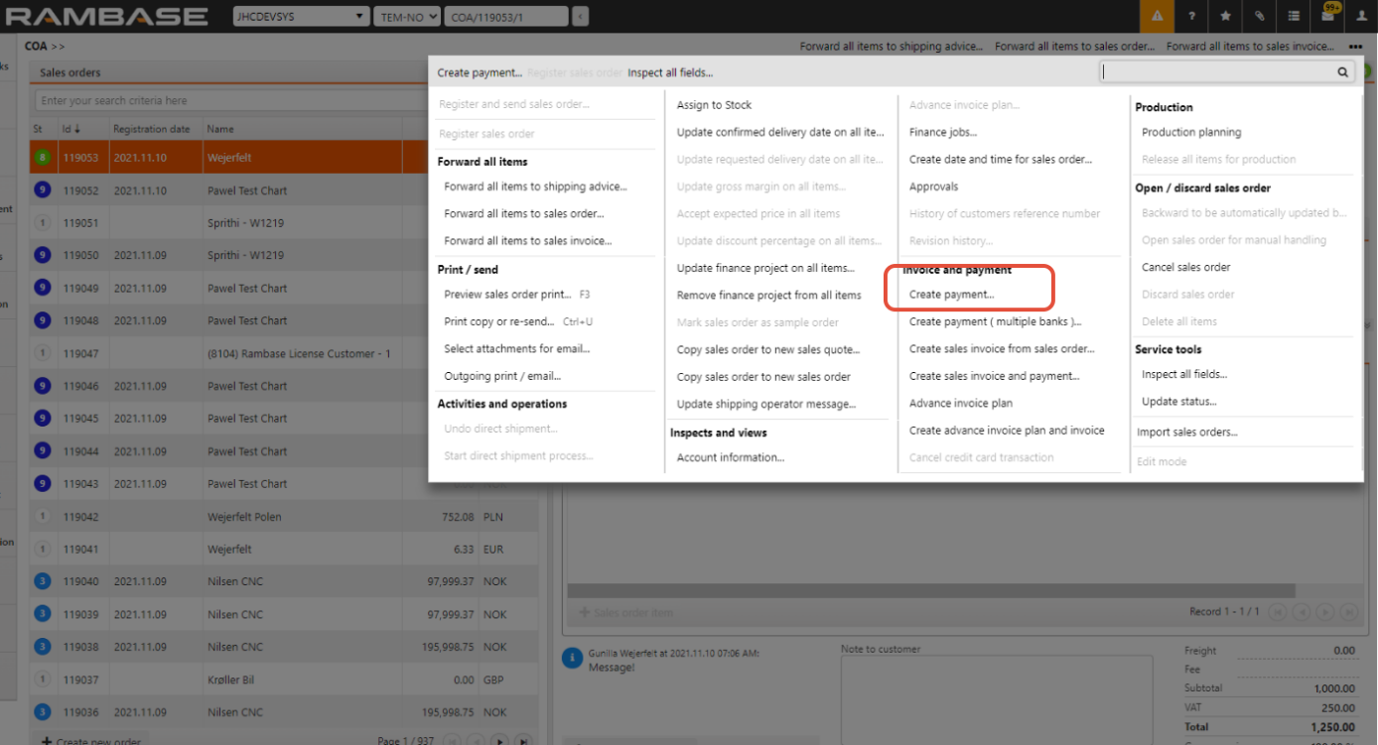
Or create a PAY and look for the COA in the field OrderRef on PAYitem. 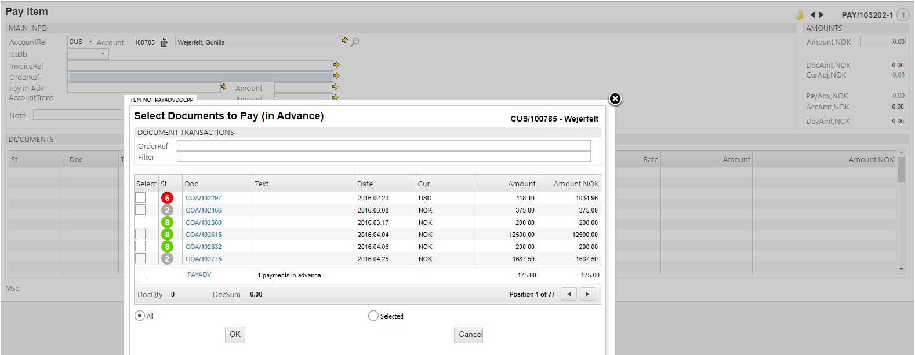

Reference to the payment is shown on COA: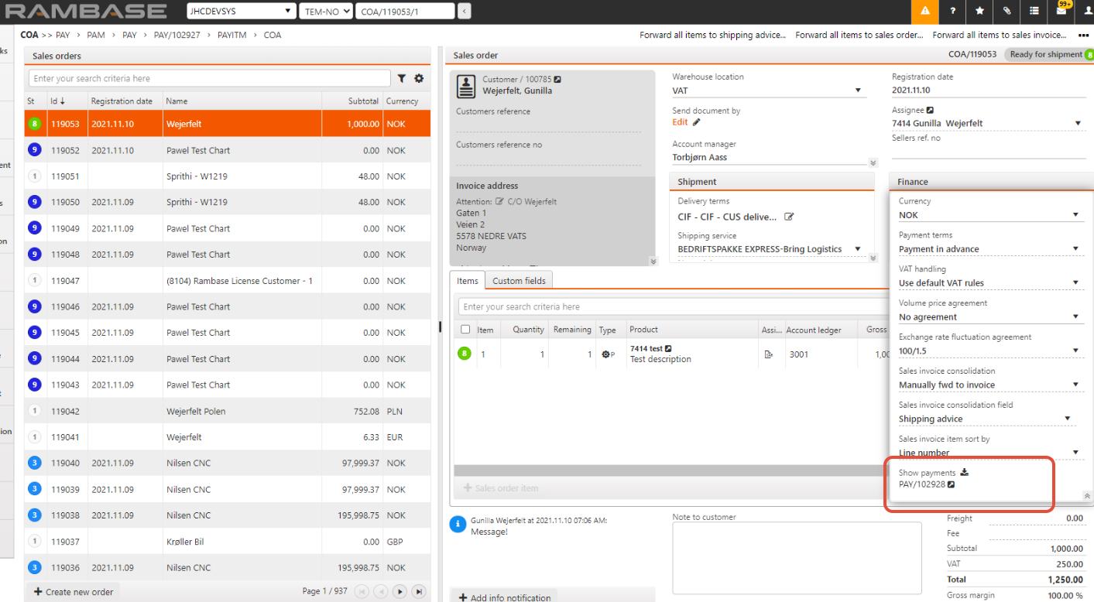

On the PAY item, you see the link to the COA and that it is a payment in advance.
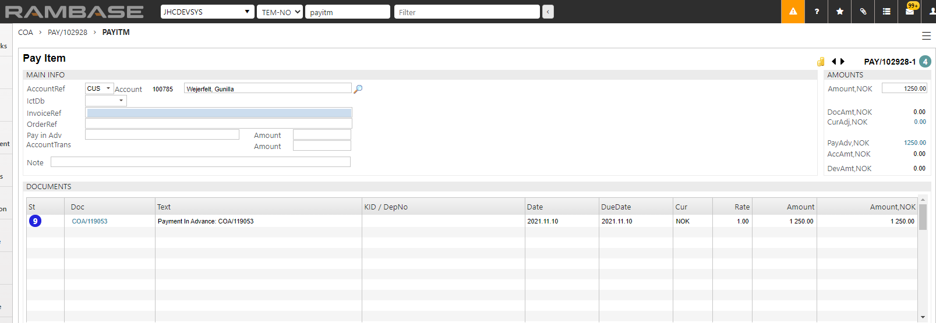

A CAT post in ST=6 is created, holding the payment in advance (will be used to clear the invoice later on).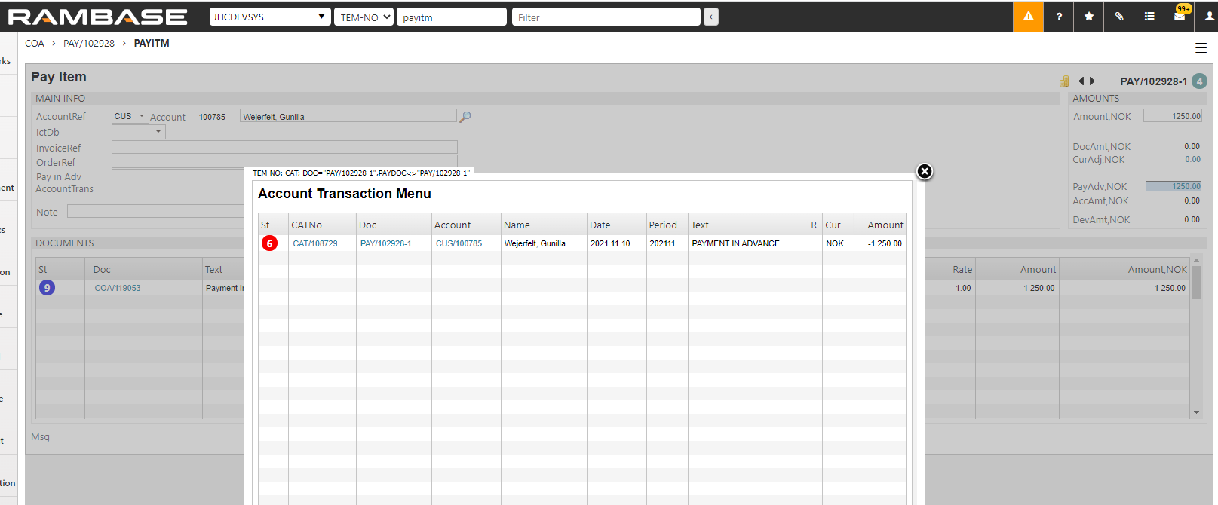

When the PAY is registered to ST=4, the note about not sending COA to shipping advice is gone and COA can be forwarded to CSA.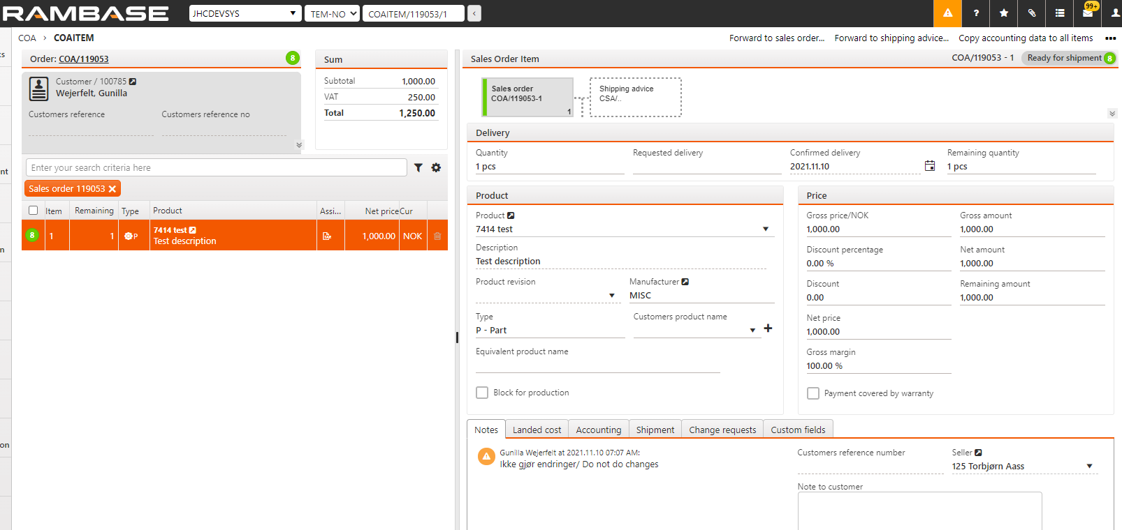
After shipping the goods, you forward the CSA to an invoice (CIN). The CIN will go to ST=9 with a reference to a PAY.
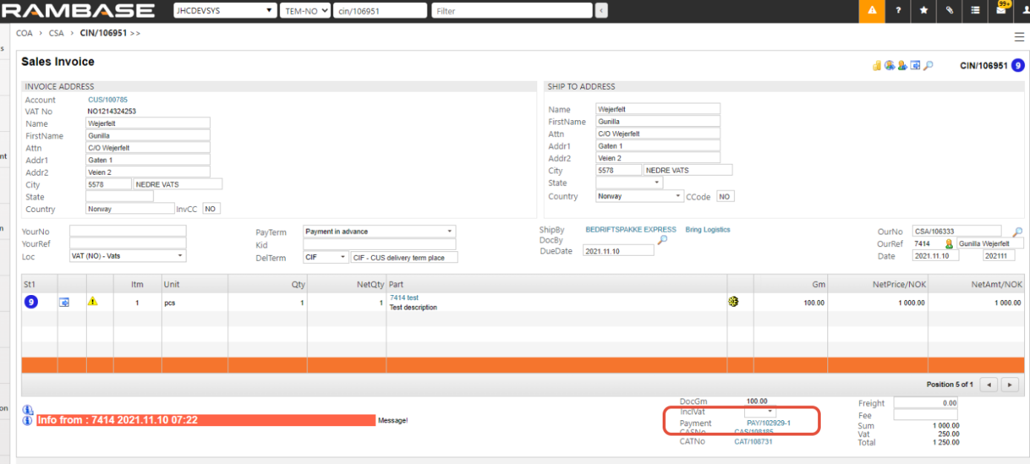

This PAY shows the clearing of the advance payment and the CIN. 